Short-Only Equity Strategy Example

- The stock is in a bear trend.
- The stock closes at a 50 day high.
- The stock belongs to the S&P500.
- The 5 day Historical Volatility reading is lower than the lowest HV reading of the prior 3 days.
- Short on the following open.
- Cover short on close if price closes lower than previous day low.
- OR exit all positions on the close of day 2.
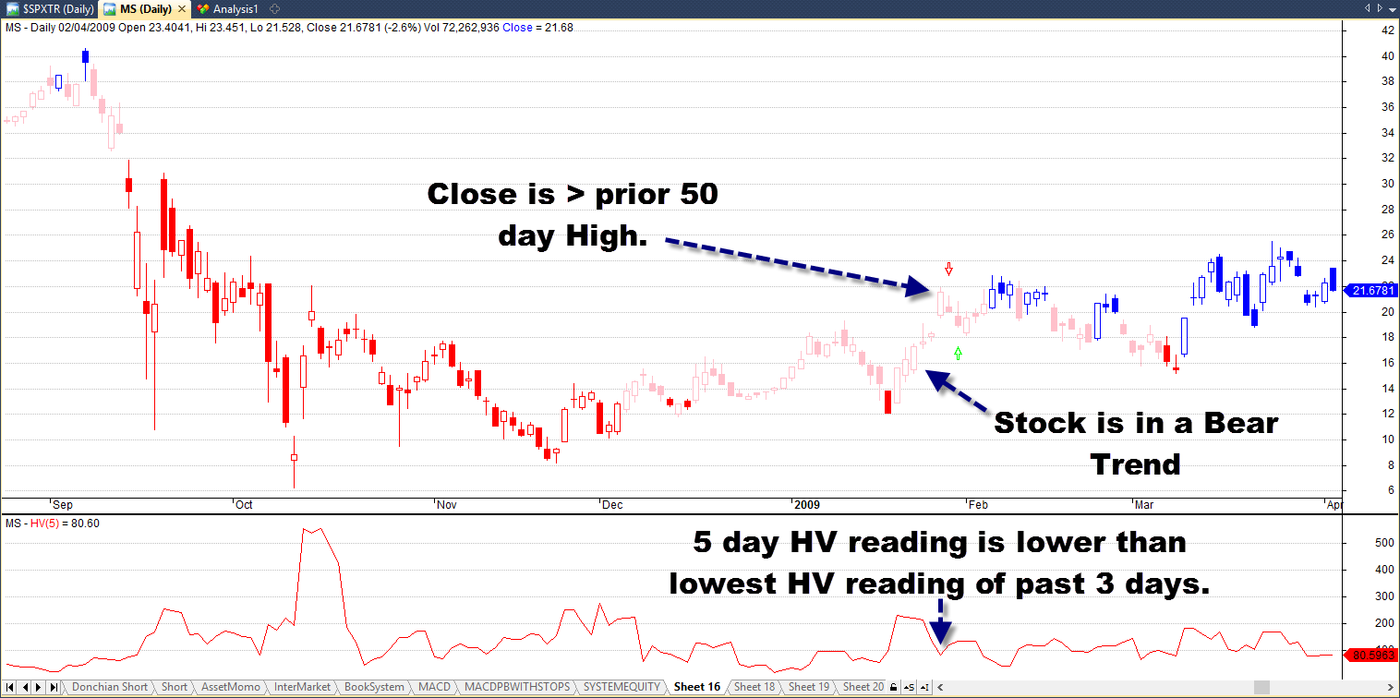

Important Characteristics of Short-Only Equity Strategies

- Very short holding periods.
- Only short very liquid stocks.
- Assume that backtest results are overstating potential profitability and understating potential risk.
- Mean reversion works better than negative momentum or trend following. I.E. Better to Short strength and Cover weakness.
- Short only strategies are often better if the long term trend of the broader equity index is a bear market.

